Test Case: tc001_SPX_Dev5_Crear_Requisicion_Spot_Tipo_Cobro_CC
Step 1 - Enter username and password and click to button Enter : Credentials Entered
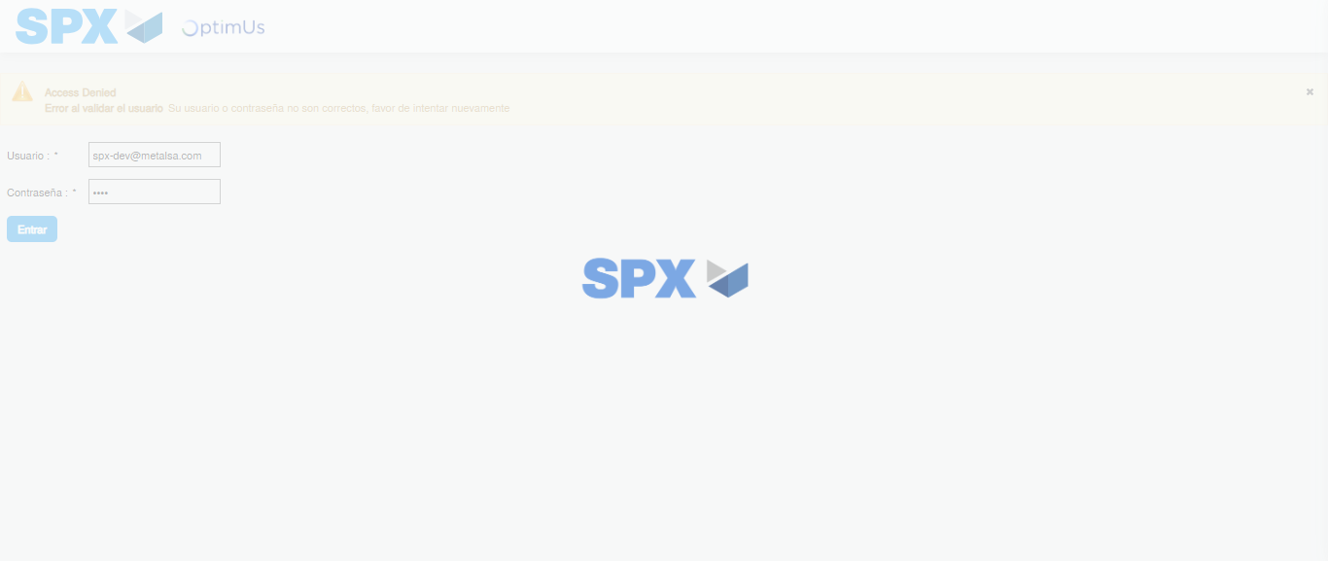Image file-name: QC_Testing-tc001_SPX_Dev5_Crear_Requisicion_Spot_Tipo_Cobro_CC-1783983973382

Step 2 - Select to UEN and Access to Spot Buy Requisitions : UEN Correctly selected and Correct access
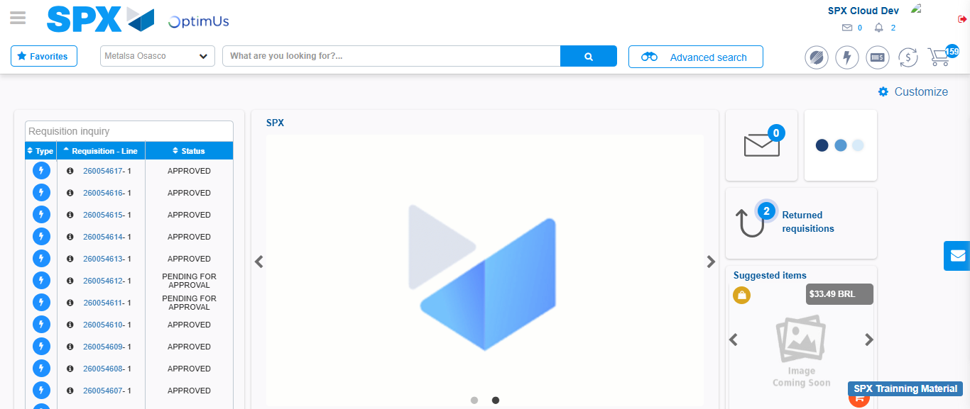Image file-name: QC_Testing-tc001_SPX_Dev5_Crear_Requisicion_Spot_Tipo_Cobro_CC-1783983999785

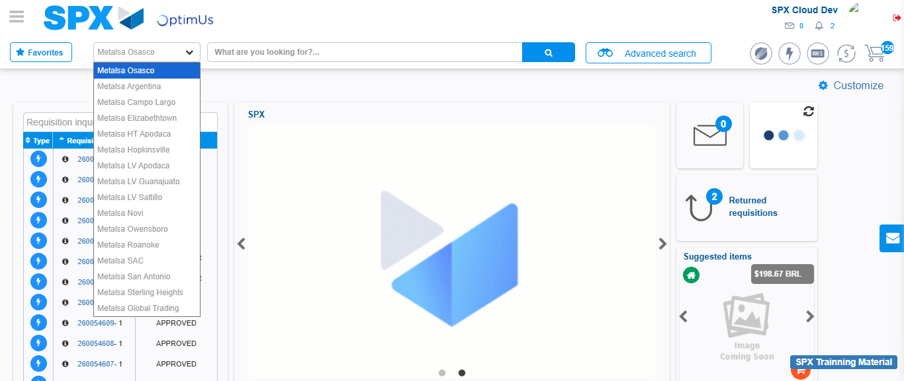Image file-name: QC_Testing-tc001_SPX_Dev5_Crear_Requisicion_Spot_Tipo_Cobro_CC-1783984002376

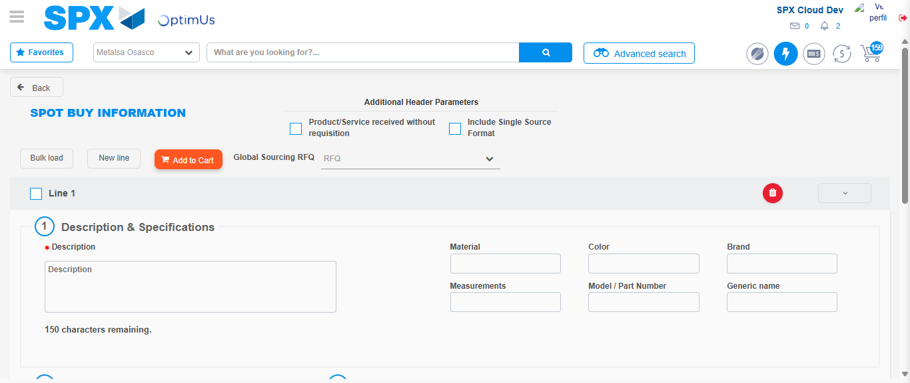Image file-name: QC_Testing-tc001_SPX_Dev5_Crear_Requisicion_Spot_Tipo_Cobro_CC-1783984022012

Step 3 - Data Capture Spot Buy Requisition : Data captured correctly
Image file-name: QC_Testing-tc001_SPX_Dev5_Crear_Requisicion_Spot_Tipo_Cobro_CC-1783984022238

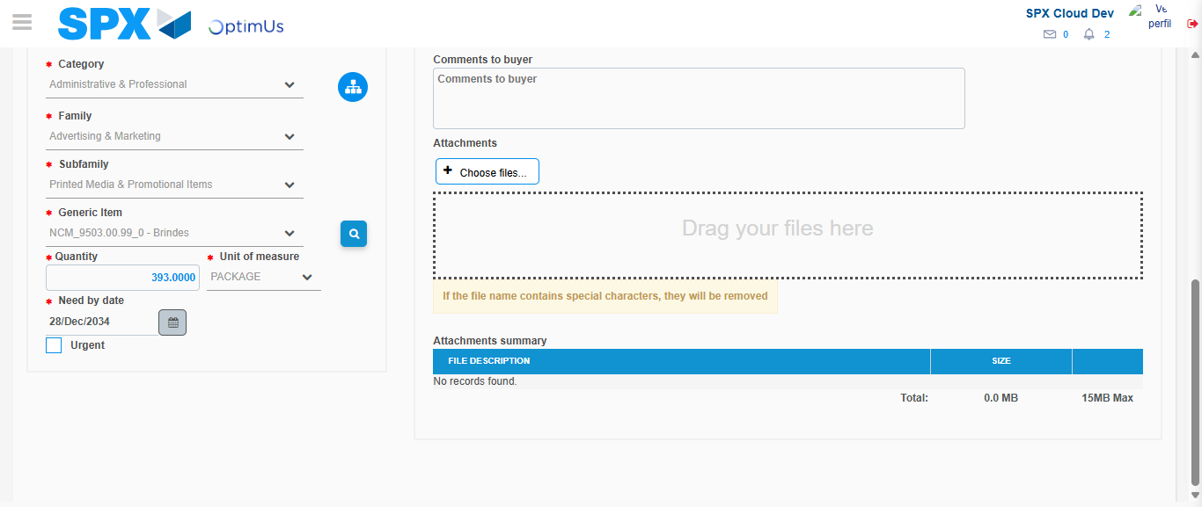Image file-name: QC_Testing-tc001_SPX_Dev5_Crear_Requisicion_Spot_Tipo_Cobro_CC-1783984034372

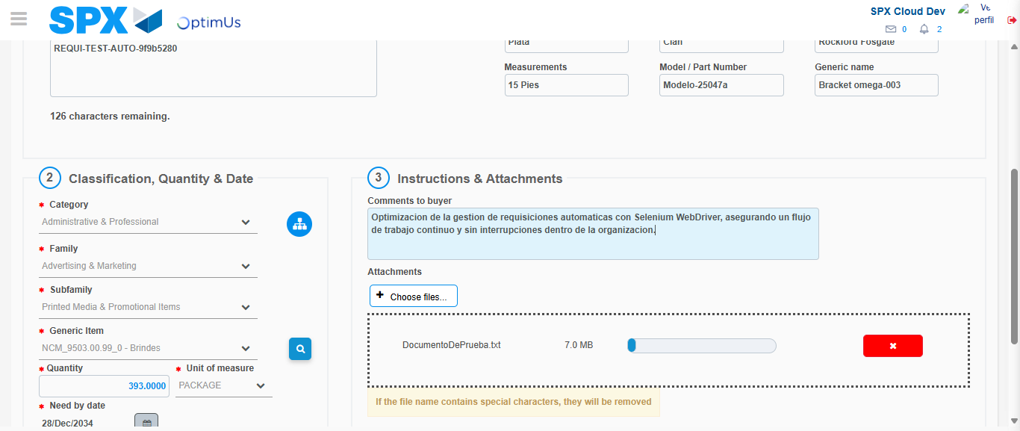Image file-name: QC_Testing-tc001_SPX_Dev5_Crear_Requisicion_Spot_Tipo_Cobro_CC-1783984035135

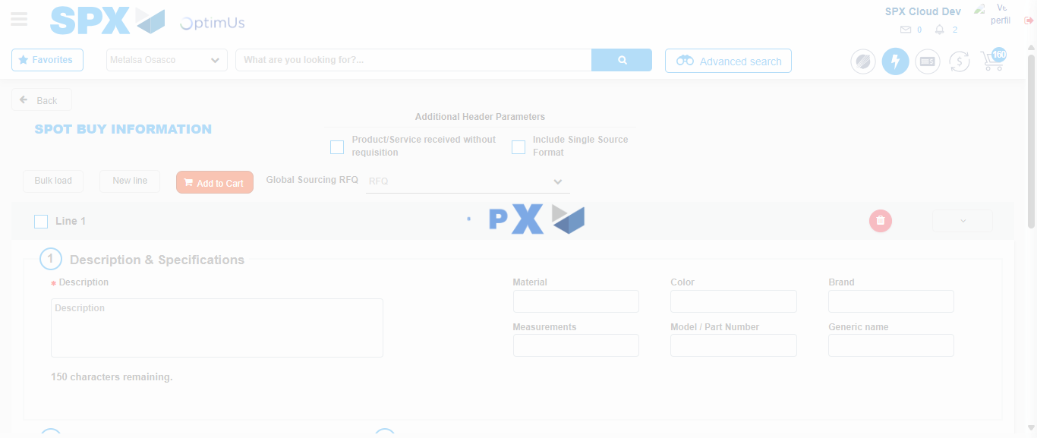Image file-name: QC_Testing-tc001_SPX_Dev5_Crear_Requisicion_Spot_Tipo_Cobro_CC-1783984045087

Step 7 - Return to Main Page SPX : Return to Main Page SPX
Image file-name: QC_Testing-tc001_SPX_Dev5_Crear_Requisicion_Spot_Tipo_Cobro_CC-1783983999785

Image file-name: QC_Testing-tc001_SPX_Dev5_Crear_Requisicion_Spot_Tipo_Cobro_CC-1783984002376

Image file-name: QC_Testing-tc001_SPX_Dev5_Crear_Requisicion_Spot_Tipo_Cobro_CC-1783984022012

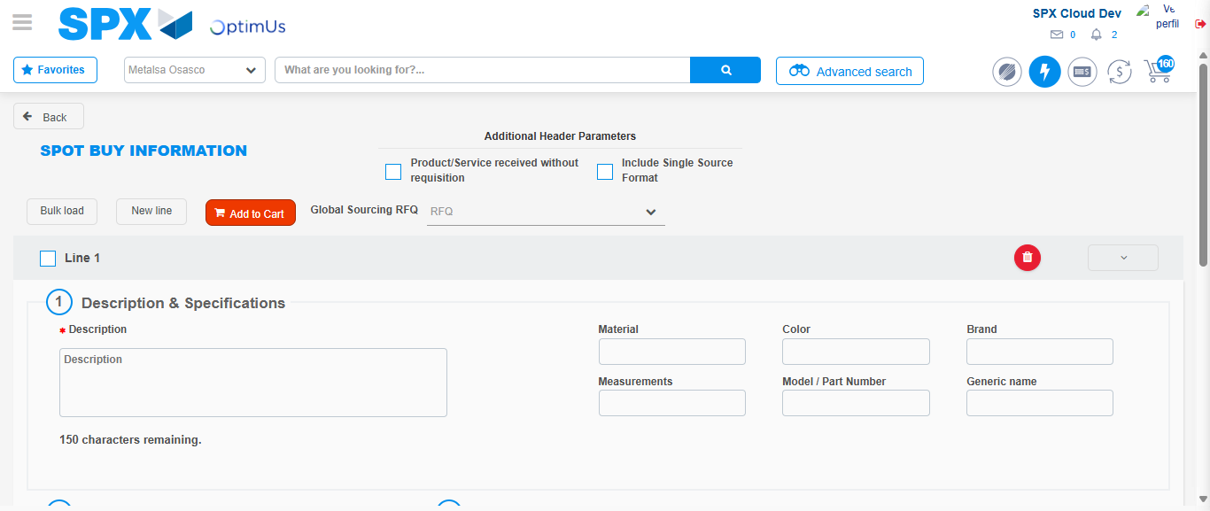Image file-name: QC_Testing-tc001_SPX_Dev5_Crear_Requisicion_Spot_Tipo_Cobro_CC-1783984047291

Image file-name: QC_Testing-tc001_SPX_Dev5_Crear_Requisicion_Spot_Tipo_Cobro_CC-1783984047469

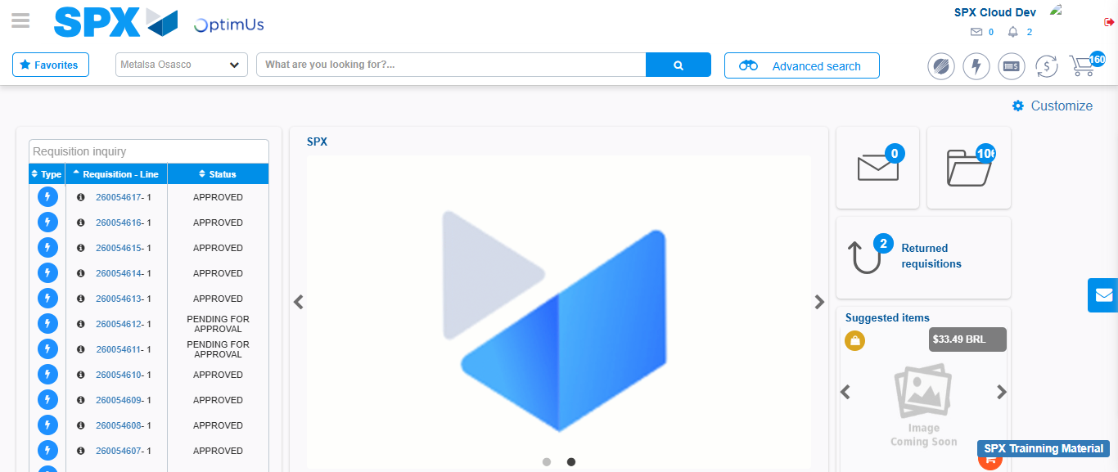Image file-name: QC_Testing-tc001_SPX_Dev5_Crear_Requisicion_Spot_Tipo_Cobro_CC-1783984068510

Step 8 - Log Out : Log Out SPX
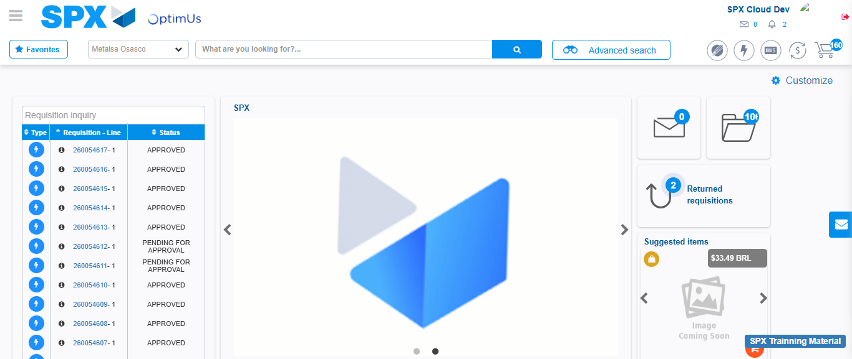Image file-name: QC_Testing-tc001_SPX_Dev5_Crear_Requisicion_Spot_Tipo_Cobro_CC-1783984068771

